EVENT LIST
In the Event list page all the upcoming events are displayed in the grid. You can see the event details for a particular event using the edit icon
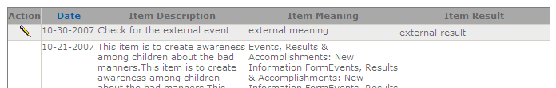 | All upcoming events are displayed in the data grid
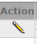 | By clicking the edit icon you can view the event details.

INTERNAL LIST
All Internal events are listed in the “Internal list” page. You can filter internal events based on “Event Type”.

All upcoming internal events are displayed in the data grid. By default the grid will display all the internal events
By clicking the edit icon you can view the internal event details.
Choose an event type to filter events based on that.

EXTERNAL LIST
All external events are listed in the “External list” page. You can filter external events based on “Event Type”.

All upcoming external events are displayed in the data grid. By default the grid will display all the external events.
By clicking the edit icon you can view the external event details.
Choose an event type to filter events based on that.
KEY LOCATION
Events are listed based on the Location where event is scheduled to happen. We can search events based on Location.
 | All upcoming events are displayed in the data grid. By default the grid will display all the events
 | By clicking the edit icon you can view the event details.
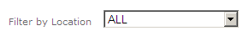 | Choose a location and event for that location is displayed. By default the
ARCHIVED EVENTS
All archived events are listed in the “archived events” page. You can filter archived events based on “Event Type”.

All completed events are displayed in the data grid. By default the grid will display all the archived events.
By clicking the edit icon you can view the archived event details.
Choose an event type to filter events based on that.

CREATE EVENT
Event creators can add a new event using this create event Menu. In the events, Results & Accomplishments: New Information Form page users can give their event details and based on the details provided events are generated.
 | Recorder name can be chosen from the list of existing names or a new recorder can be added through the “Add New” link
 | If you check this box, events will not be listed to public. It is available for the logged users only
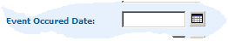 | Specify the Date on which the event is scheduled to occur.
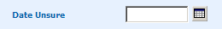 | If the event date is not decided then choose a tentative date for the event
 | Specify the source of the Event. By default the event source will be set as “Internal” All internal and external events will be listed separately in the Main page.
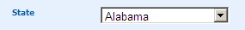 | Choose a state from the list of states where the event is scheduled to happen.
 | Give the name of the Sponsor who sponsors the event
 | Specify the Location where Event is scheduled to take place
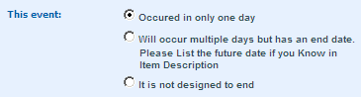 | This talks about the event recurring period. Choose “Occurred in only one day” if the events occurs on only one day.  Choose “Multiple days but has an end date” option if the event is scheduled to occur on more than one day but has a scheduled end date.  Choose “It is not designed to end” if the event is a never ending event.
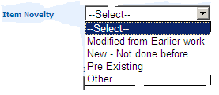 | Item Novelty tells about the item innovation. The item can be a new item or an existing one or may be a modified from the earlier work. Choose one of the options to specify about the nature of your Item.
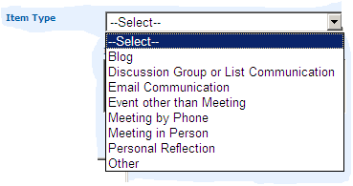 | Choose an item type from the list of item types
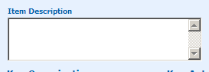 | Give a description about your item. Briefly outline what happened so that people outside your organization can understand
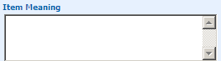 | Give the Meaning for your item. I.e. Why and how is this item important to the mission, objectives or work you are recording for?
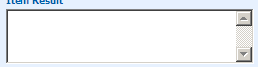 | State the outcome or result or consequence of the recorded item
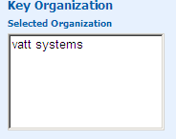 | This gives the list of most important organizations. By default when an actor is chosen the actor’s organization will be loaded.
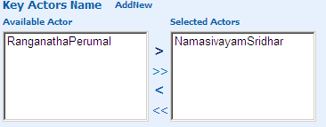 | The actors who are all important in the creation and in the item are shown in the “Key Actors Name”. The Available actors are listed in the list and you can choose an actor of your choice or add an actor through the “Add New” link.

EVENT GOALS
Events are conducted to achieve a specific goal. The Event organizers can choose any of these goals or state their own goals other than the listed goals. More than one goal can be chosen for an event.
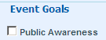 | Check this check box if the item relates to public awareness i.e. related to media(TV, Radio, print, cable, web)
 | Check this check box if the event goal is related to technology.
 | Check this check box if the event goal is related to Research, best practices search and evaluation
 | Check this check box if the event goal is related to training and education
 | Check this check box if the event goal is related to Resource Development namely bringing in/developing people and organization
 | Check this check box if the event goal is related to strategic special events or products
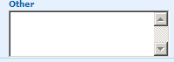 | If your event goal is other than the specified list of goals state the event goals in the other text box.

EVENT TYPE
The Events are conducted to have a specific result. The Event results are grouped under different event type category. You can choose an event type from the specified event types or give your own event type in the “Others” text box. You can check more than one check box. Based on the priority of the event result you can mark them on a scale of 1-10 1 being the lowest and 10 being the highest. By default the rank will be stored as 10.
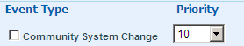 | Check this check box if the event resulted in a creation or modification of any community or system.
 | Check this check box if the event resulted in media related to your organization.
 | Check this check box if the event resulted in Community action or change
 | Check this check box if the event resulted in funding, materials and services to your organization.
 | Check this check box if the event resulted in offering or providing a service by your organization to a person, client, or group
 | Check this check box if the event result was an event or action to plan or develop your organization or its related work
 | Check this check box if the event result was an event or action that positively or negatively influenced your organization or its work.
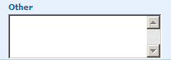 | If your event type is other than the specified event types specify it in the “Other” text box area.

EVENT COMMUNICATION
Event communication is a way to communicate the. You can choose a communication type from the list or specify your own communication type. You can choose more than one communication type.

 | Check this check box if the event has to be included in organizational reports or related document.
 | Check this check box if the event is a special event.
 | Check this check box if it is a best practice.
 | Check this check box if the you want to share this event through mail.
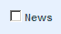 | Check this check box if the event can be shared through news or through media
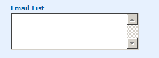 | You can specify the list of e-mails separated by comma with whom you want to share.
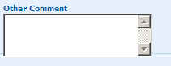 | Other comments related to event communication can be given here.

UPDATE EVENT
Event details, Results and Accomplishments can be updated using the edit icon in the Event home page or from the Search page. While updating the event details we can add a new recorder name, change the existing recorder name, add a new actor to the event or change the actor. We can change the item novelty, and Change the Item type.
Event type, Event goal and Event communication can also be changed.

EVENT HOME

In the Event home page all the Item Details for the current month are displayed. The Dashboard gives the list of “completed” and “scheduled” events. The days on which event exist are highlighted in the calendar. The Data grid will display the Items for the current month and it will display only scheduled events
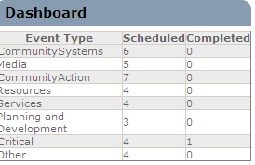 | Dashboard gives the List of scheduled and Completed Events based on the Event type. All on going and up coming events are grouped under Scheduled” and all completed events are grouped under “Completed”. The Dashboard will give the Status for the “Current month”
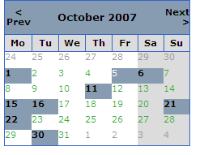 | The calendar will highlight the days on which the event exist for a current month.
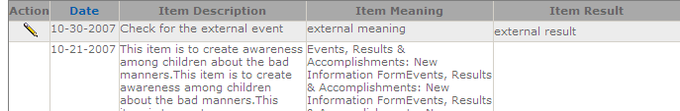 | The grid displays the scheduled items for the current month.
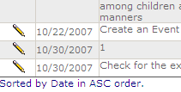 | The item grid can be sorted based on the Date either in the Ascending order or Descending order.
 | By clicking the edit icon you can update/ edit event information.

ADDRESS BOOK

Through the Address book Administrators/Users can add new user information. The user can be either added as an actor or a recorder. The user information can be searched alphabetically, by city and State. You edit user information, sort the user grid.
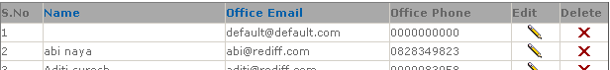 |  | The grid displays the entire active user by default at the page load time.
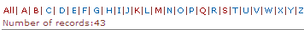 |  | Users can be filtered based on their starting letter. For example if you choose “A” all the users whose name start with “A” are all listed.
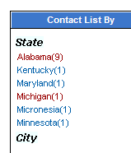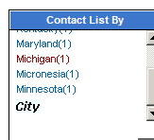 |  | Users can be filtered based their Cities and state. Choose a state/City from the list of available states and city and corresponding users will be displayed in the grid. You can scroll the “contact list by” panel by cicking at the bottom of the right extreme of the panel to view all the states and cities
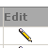 |  | User information can be edited by clicking the “Edit” icon
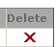 |  | Users can be deleted using the “Delete” icon. All the deleted users will be grouped as “Inactive users”
 |  | If you click the “Show all” link all the “Active” and “Inactive” users will be displayed
 |  | If you click the “Active user ” link all the “Active” will be displayed
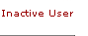 |  | If you click the “Inactive user ” link all the “Inactive” users will be displayed
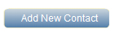 |  | Click this button to add a new contact information
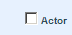 | Check this check box if you want the user to be added as an “actor”
 | Check this check box if you want the user to be added as a “recorder”
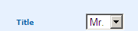 | By default the “Title” will be set as “Mr.”
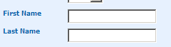 | You need to specify first name, last name, Office phone number and office e-mail id to create an user account.
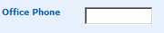 | You need to give only 10 digits for the phone number

SEARCH
In the search page by default all records will be displayed. You can choose single search criteria or combinations of search criteria.

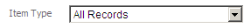 | Choose an item type and click search to see the events corresponding to the chosen item type.
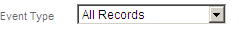 | Choose an Event type and click search to see the events corresponding to the chosen event type.
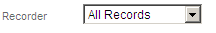 | Choose a Recorder name and click search to see the events corresponding to the chosen Recorder name
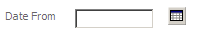 | Choose Event occurred Date and click search to see the events corresponding to the Date
 | Choose a state where the event is scheduled to occur and click search to see the events corresponding to the State
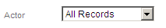 | Choose an actor name and click search to see the events corresponding to the chosen actor name
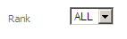 | Choose a rank and click search to see the events corresponding to the Rank.
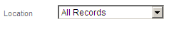 | Choose a Location where event is scheduled to occur and click search to see the events corresponding to the Location.
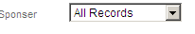 | Choose a sponsor name and click search to see the events corresponding to the chosen sponsor.
 | The grid can be exported to either Excel or word. Do the search operation and click on excel or word to import the contents
 | The Item information can be edited by clicking the edit icon.

